Related files :
- start_snapshot_auto_delete.sh
- start_snapshot_auto_delete.py

Steps :
- Check if a shell script start_snapshot_auto_delete.sh exists in this path /opt/res/homes/res/scripts if not, you can copy from your installed RAPIDSnapshot folder.
- Run a command to call start_snapshot_auto_delete.sh and pass parameters as detail below

  - JDBC string for the connection detail (Format jdbc:oracle:thin:<<SCHEMA_USERNAME>>/<<SCHEMA_PASSWORD>>@<<DB hostname>>:<<DB Port Number>>:<<DB SID>>)
Example :

Schema username : xx_rs_taty_221_nu
Password : xx_rs_taty_221_nu
DB Hostname : oratest90.rapidesuite.com
DB Port Number : 1521
DB SID : erpp

JBBC String will be jdbc:oracle:thin:xx_rs_taty_221_nu/xx_rs_taty_221_nu@oratest90.rapidesuite.com:1521:erpp

Remark : DB Hostname, DB Port Number, DB SID value are the same thing which we ask for Schema Creation.

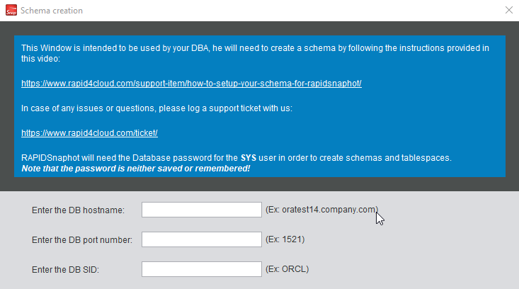

  - Age (Unit is days , value can be any positive integer)
For example : Today is Oct 22nd and we want to delete snapshots which are older than 12 days, so we just put 12 for it and snapshots which are older than Oct10th will be deleted.
  - Delete Type (value can be P for Physical Delete, S for Soft Delete)
  - Include soft deleted snapshots (value can be Y if including soft deleted snapshots, N if not including soft deleted snapshots)

Example command
1. This command means we will soft-delete snapshots which have Snapshot Date (SNAPSHOT. CREATED_ON) are older than current date-12 days
/opt/res/homes/res/scripts/start_snapshot_auto_delete.sh jdbc:oracle:thin:xx_rs_taty_221_nu/xx_rs_taty_221_nu@oratest90.rapidesuite.com:1521:erpp 12 S

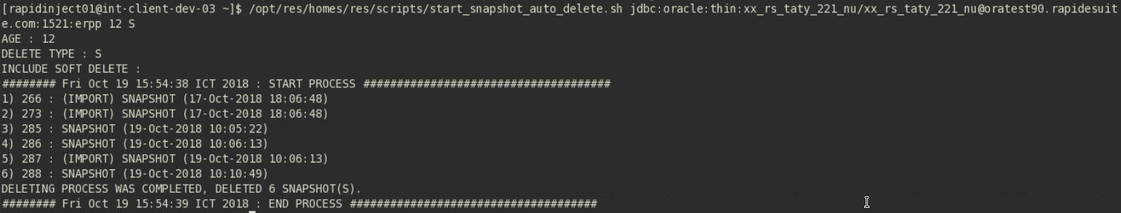

2. This command means we will physical-delete snapshots which have Snapshot Date (SNAPSHOT. CREATED_ON) are older than current date-16 days and do not include any soft-deleted snapshots.
/opt/res/homes/res/scripts/start_snapshot_auto_delete.sh jdbc:oracle:thin:xx_rs_taty_221_nu/xx_rs_taty_221_nu@oratest90.rapidesuite.com:1521:erpp 16 P N

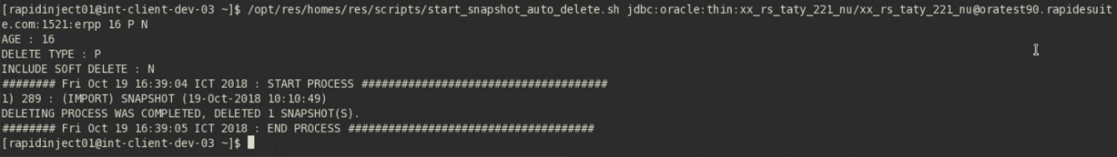

3. This command means we will physical-delete snapshots which have Snapshot Date (SNAPSHOT. CREATED_ON) are older than current date-16 days and do not include any soft-deleted snapshots.
/opt/res/homes/res/scripts/start_snapshot_auto_delete.sh jdbc:oracle:thin:xx_rs_taty_221_nu/xx_rs_taty_221_nu@oratest90.rapidesuite.com:1521:erpp 15 P Y

